Using relevant costs
An online drop shipping store purchases running shoes in the spring for $31/pair and sells them during the spring and summer for $50/pair. In the autumn, the demand for running shoes dwindles. The store has two choices: (i) it can sell out its remaining inventory of so pairs by having an end-of-summer sale of $29.99/pair, or (ii) it can hold the shoes in inventory until next spring (eight months hence) and sell them for $39.99/pair. (It cannot get $50 because of new models from the manufacturer in the spring.) Should the store close out the inventory or hold onto them until next spring?

1. What costs matter?
- The store already paid $31 per pair in the spring.
👉 That $31 is a sunk cost – it’s gone either way, so it is not a relevant cost for this decision.
We only care about what happens from today forward.

2. Two choices (per pair)
- Sell now at $29.99
- Hold 8 months and sell next spring at $39.99
But if we sell later, our money is tied up in inventory, which uses working capital.
From your notes, the opportunity cost of capital is 20% per year.
So if we sell now, we could take the $29.99 and earn 20% interest on it for 8 months.

3. Future value of selling now (include opportunity cost)
Treat 20% as the cost of capital and use (approximate) compounding for 8 months:
$$\text{Future value of selling now}≈29.99×\left(1+0.20×\frac{8}{12}\right) \\ ≈29.99×(1+0.1333)≈29.99×1.1333≈34$$

Or 29.99(1+(0.20/365))^8*30 (the way we did it in class)
- 8*30 = total days for the 8 months
So if we sell now, that money could grow to about $34 next spring.
(You can also think of this as:
Opportunity cost of waiting = interest we could have earned on 29.99.)

4. Compare to selling next spring
- Sell now (then invest): worth ≈ $34 next spring
- Sell next spring: $39.99 next spring
Difference:
$$39.99-34≈6$$
So even after charging ourselves for the opportunity cost of working capital, holding the shoes earns about $6 more per pair.

✅ Final decision (Profitability Analysis)
- Relevant comparison:
Future value if we sell now vs revenue if we sell later
- Result: Selling later gives a higher profit per pair.
👉 The store should hold onto the inventory and sell the shoes next spring for $39.99/pair.

Profitability Analysis
One major task of a business analyst is to gauge the impact on profits when one of the variables changes. For example, the price or cost might change. A typical question for the analyst is whether the sales quantity should change—and by how much—to compensate for the loss in profits. The variables include price, variable cost, fixed cost, and the quantity sold. What percentage change in sales quantity is needed to maintain the same level of profit when the price, variable cost, or fixed cost changes?

Illustrative problem:
A social media platform serves 1,000 users per period, each paying a subscription fee of $5.00. The variable cost per user per period is $3.00, and the fixed cost per period is $2,000.
- Calculate current profit = Revenue – Total Cost
  - Total Cost = Fixed Cost + Variable Cost (variable cost/period * users/period)
    - = 2000 + 3000 = 5000
  - Revenue = price/unit * # of units sold
    - = 1000 * 5.00 = 5000
  - Calculate current profit = Revenue – Total Cost
    - = 5000 – 5000 = 0
    - The platform is breaking even here — no profit, no loss.
- If the platform increases the subscription fee by 10%, how many users can it afford to lose while maintaining the current profit level? What percentage of users can the platform afford to lose?
  - To calculate the new subscription fee, first find 10% of the original $5.00 fee by multiplying $5.00 by 0.10, which equals $0.50. Add this increase to the original price ($\$5.00+\$0.50$), resulting in a new total subscription cost of $5.50.
    - Total Cost = Fixed Cost + Variable Cost (variable cost/period * users/period
      - = 2000 + 3000 = 5000
    - Revenue with 10% sub increase = price/unit * # of units sold
      - = 1000 * 5.50 = 5500
    - Calculate profit with 10% sub increase = Revenue – Total Cost
      - = 5500 – 5000 = 500
    - Now, we need to make sure our profit level is the same as before, which is $0.
      - To figure that out, we look at how much profit each user brings in after the price increase.
        - Each user pays $5.50, and it costs $3.00 to serve them, so the company makes:
          - $5.50-3.00=2.50$
            - Each user gives the company $2.50 of profit.
      - Every time 1 user leaves, the company loses $2.50 of profit.
      - The question now is:
        - How many users must leave for the company to lose the entire extra $500 it gained?
          - 500/2.50 = 200 users
          - The platform can afford to lose 200 users, which is 20% of its user base.
            - 1000 – 200 = 800 (which is 20% of 1000)
- Instead of increasing the fee, suppose the variable cost decreases to $2.00 per user. How many users must the platform retain to maintain the same level of profitability?
  - Calculate profit = Revenue – Total Cost
    - Total Cost = Fixed Cost + Variable Cost (variable cost/period * users/period)
      - = 2000 + 2000 = 4000
    - Revenue = price/unit * # of units sold
      - = 1000 * 5.00 = 5000
    - Profit = Revenue – Total Cost
      - = 5000 – 4000 = 1000
      - =5.00 – 2.00 = 3.00
      - 1000/3.00 = 333.33 ~333 users will be lost
        - 1000 – 333 = 667 users. The platform must retain 667 users to maintain the same level of productivity.
- Suppose instead that the fixed cost decreases by 20% (20% of 2000 = 400 2000 – 400 = 1600). How many users must the platform retain to maintain the same level of profitability?
  - Calculate profit = Revenue – Total Cost
    - Total Cost = Fixed Cost + Variable Cost (variable cost/period * users/period)
      - = 1600 + 3000 = 4600
    - Revenue = price/unit * # of units sold
      - = 1000 * 5.00 = 5000
    - Profit = Revenue – Total Cost
      - = 5000 – 4600 = 400
      - =5.00 – 3.00 = 2.00
      - 400/2.00 = 200 ~200 users will be lost
        - 1000 – 200 = 800 users. The platform must retain 800 users to maintain the same level of productivity.
- BREAK-EVEN if the price is $5.50, variable cost is $2.00, and the fixed cost is $1600 (without elasticity).
  - Revenue = Cost
    - 5.50u = 1600 + 2u
    - 5.50u – 2u = 1600
    - 3.50u = 1600
    - U = ~457
      - What number of users would be needed to break even if people did NOT react to price changes?
- If all the above changes occur simultaneously and the price elasticity of user sign-ups is -4.0 (negative 4), evaluate whether these changes would lead to higher profitability compared to the current level.
  - Fixed cost = 1600
  - Variable cost = 2.00
  - Subscription Fee = 5.50
  - Price of elasticity = -4.0
    - The number is negative → when price goes up, users go down.
    - The 4 means users are very sensitive to price.

  - 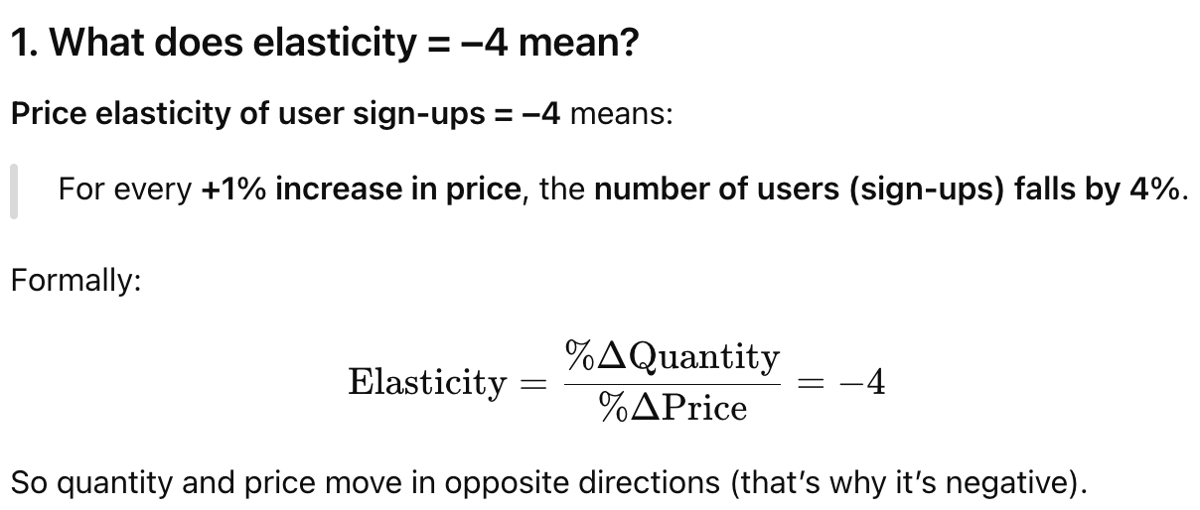
  - Price Elasticity = % change in demand or quantity / % change in price
    - -4 = Q/10% =
      - -40% = Q
        - To make it positive, we would do 1 – 0.40 = 0.60
          - 60% of the original
            - 60% of 1000 users 600
  - Calculate profit = Revenue – Total Cost
    - Total Cost = Fixed Cost + Variable Cost (variable cost/period * users/period)
      - = 1600 + 1200 = 2800
    - Revenue = price/unit * # of units sold
      - = 600 * 5.50 = 3300
    - Profit = Revenue – Total Cost
      - = 3300 – 2800 = 500
        - $500 profit These changes would lead to higher profitability compared to the current level at $0.
  - Elasticity of -6 would not be profitable; the number of users would be less than 457.
  - Price Elasticity of Demand (What do different types of elasticity tell us?)
Elasticity Value | Type | Meaning | How People React to Price Increases | Extra Notes
0 | Perfectly Inelastic | People do NOT change quantity at all | Buy the exact same amount | Rare. Usually essentials like life-saving medicine.
Between 0 and –1 | Inelastic | People react a little | Buy slightly less | They still buy because they need it.
–1 | Unit Elastic | % change in Q = % change in price | Price ↑ 10% → Quantity ↓ 10% | Borderline case between elastic and inelastic.
Less than –1  (e.g., –2, –3, –4) | Elastic | People react strongly | Buy MUCH less | Small price changes create big changes in users.
Positive  (e.g., +1, +2) | Veblen / Unusual Goods | People buy more when price rises | Buy more | Happens with luxury/status items (“expensive = better”).
Business case situation: Consider the situation of an online fashion store that stocks 2,500 units of pashmina shawls for $80 per unit, with a profit contribution of $20 per unit to the store’s overhead costs. The store typically sells half of the stock in the first year, while the remaining stock goes into inventory for future sales. This situation is similar for most other types of shawls in stock. Consequently, there is a natural increase in the store’s working capital.
A consultant evaluates the situation and recommends running a half-price sale on all slow-moving items. However, the store owner responds, "We cannot cover the costs of the shawls; eliminating the gross margin we have will not solve the problem."
How would you approach this problem and advise the store on a profitable course of action? Make any relevant assumptions needed.

Underestimating the importance of sample size
Imagine two hospitals: a large one that handles thousands of births each year, and a small one with a few hundred births annually. Which hospital do you think would have more days where more than 60% of the babies born were boys?
Imagine two hospitals:
- A large hospital with thousands of births each year
- A small hospital with only a few hundred births
Which hospital will have more days where more than 60% of the babies born are boys?
➡️ Answer: The smaller hospital.

Why? (Simple Explanation)
Sample size matters.
Smaller samples have more randomness, so their percentages can jump around a lot.
Bigger samples stay closer to the true average, which is about 50% boys and 50% girls.

Statistical Concept: Confidence Interval
A confidence interval tells us how much a percentage can change just by chance.

Small Hospital
- Small sample → wide confidence interval
- Percentages swing up and down more
- Having more than 60% boys on a given day is common

Large Hospital
- Large sample → narrow confidence interval
- Percentages stay close to 50%
- Harder to get extreme days like over 60% boys

Key Takeaway
The smaller hospital has more days with over 60% boys because small sample sizes create wider confidence intervals, leading to more variation in the data.
Importance Concepts:
  - Working Capital
    - Definition: Money a business needs to run day-to-day (inventory, bills, operations).
    - Formula:$\text{Working Capital}=\text{Current Assets}-\text{Current Liabilities}$
    - Why it matters:
      - Shows how easily a business can pay for short-term needs
      - Low working capital → cash problems
      - High working capital → good liquidity

⭐ 2. Compounding (Daily Compounding)
When money grows because you earn interest on top of interest.
Daily compounding formula:
$$A=P{\left(1 + \frac{r}{365}\right)}^{365t}$$
Key idea:
- More compounding periods → more growth
- Daily > Monthly > Yearly

⭐ 3. Opportunity Cost
The value of the next best thing you give up.
Example:
Choosing an older car vs. a newer car (put them next to each other)
→ Opportunity cost = what you lose by not choosing the other option.
Used in decisions like:
- Selling now vs. holding inventory
- Working vs. going to school
- Using your money for one project vs. another

⭐ 4. Cannibalization
When a company’s new product steals sales from its own older product.
Example:
- New iPhone reduces sales of last year’s iPhone
- New Starbucks drink steals sales from existing drink

⭐ 5. Profitability Analysis
Basic formula:
$$\text{Profit}=\text{Revenue}-\text{Total Cost}$$
Revenue:
$$\text{Price}×\text{Units Sold}$$
Total Cost:
$$\text{Fixed Cost}+(\text{Variable Cost per unit}×\text{Units})$$
Purpose:
- To decide if something is worth producing, selling, or continuing.

⭐ 6. Fixed Cost vs. Variable Cost
Fixed Cost | Costs that don’t change with number of units | Rent, salaries, insurance
Variable Cost | Cost per unit that changes with sales | Materials, shipping, per-user fees
Why it matters:
Used to calculate break-even point and profit changes.

